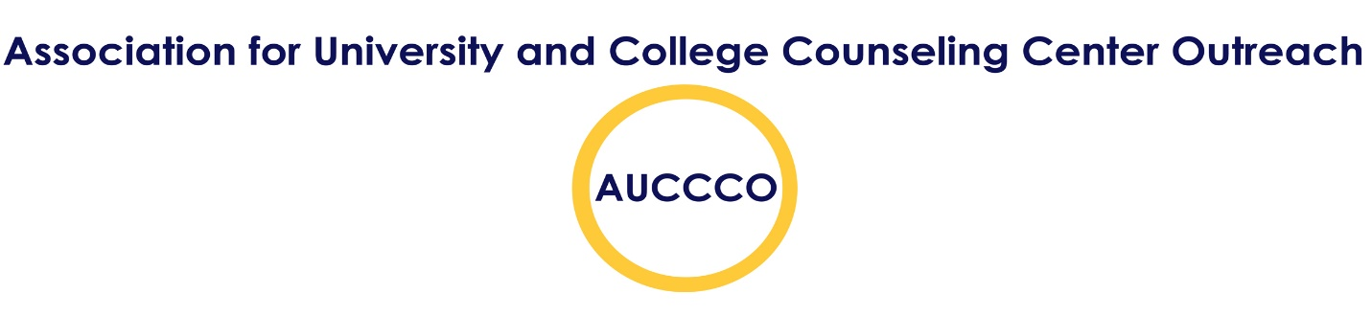
Description of Activities for the AUCCCO Board of Directors
Thank you for your interest in becoming a member of the AUCCCO Board of Directors. It is an exciting opportunity to be a part of a team that leads a growing, national organization. As a board member you will work closely with other innovative thinkers to help advance the AUCCCO mission: to assist professionals involved in the leadership of outreach, consultation, and campus community interventions. AUCCCO provides opportunities for networking, professional identity development, idea exchange and creating standards for quality outreach services. AUCCCO promotes a broad understanding of outreach, prevention and education services based on the assumption that outreach must extend the expertise of counseling centers to the larger campus community. AUCCCO recognizes that, as the campus climate has a profound influence on students’ lives, outreach services must be informed by perspectives that address the intersection of multiple social identities, promote social justice, and celebrate diversity in all its forms. The Board of Directors establishes policy and procedures for the Association in keeping with its stated objectives.
Members of the Board must be from active member institutions, in good standing with the organization, and employed in counseling centers. The first step in becoming a Board Member is to have a discussion with your Director about the support you would need from your center in terms of time and funding, which would include:
- Two in-person meetings per year (the expectation to make every reasonable effort to attend each semi-annual meeting):
1. In June, in conjunction with the annual AUCCCO Conference. The commitment is to arrive on Monday of the conference week for Tuesday meetings and stay after its conclusion on Friday afternoon. This may require 1 or 2 extra nights on your hotel stay, as well as one meal a day, at the cost of your center. This also requires an understanding that you will be away from your office that entire week in professional development activities. Total cost = 2 days away from the center and an estimated extra $350-400 in expenses (apart from regular conference expenses.
2. Mid-year Board of Directors meeting in January. These have been held over a weekend to minimize time away from our respective centers. Members of the Board are expected to arrive Thursday evening in anticipation of two days of meetings on Friday and Saturday. Sunday is a designated travel day as well. AUCCCO is currently capable of funding the hotel rooms (shared) and one meal per day. Board members receive funding from their centers to cover travel to and from the meeting and two meals per day. Total cost varies depending on location but will involve 2 days away from the center and the potential cost of $500-1,000
- Board meetings conducted periodically via telephone conference call or by other electronic means. These meetings typically last 2 hours and are held quarterly. No financial cost, but does require time during your workday.
- Board business conducted throughout the year via email that may require some attention. Time cost varies by assignment.
- Participation on and chairing standing committees: Diversity/Inclusion, Social Media, Mentoring, Membership, Conference and Proposal Review, Website Management, and Assessment & Research. Time costs vary by assignment.
Board members are elected to serve 2-year terms, and must be willing to consider running for one of the Executive Committee positions: President, Treasurer, or Secretary. Participation in an exec position could extend your Board involvement for up to three years, depending on the position. Time costs vary according to assignment and position. There will be some time given to AUCCCO activities each week as a member of the Executive Committee.
The Board of Directors is currently working to build a budget that would allow the association to cover board activity expenses. Center directors can be referred to Kelly Thorne (Kelly.Thorne@uvm.edu) or Teresa Michaelson (Teresa.Michaelson@ucf.edu) with questions related to the financial commitment. Participation will be one of the most rewarding and enriching professional experiences you will experience in your career. You will not only make connections far and wide, you will also improve your outreach and prevention work for your center and campus community. Thanks for your interest. Best of luck as you move forward in considering a position on the AUCCCO Board of Directors.
Sincerely,
Kelly Thorne, PsyD President, AUCCCO

Helpful Links:
http://auccco.com/Board-of-Directors
http://auccco.com/Becoming-a-Board-Member

